**Index**

|  |  |  |  |
| --- | --- | --- | --- |
| **Sr.No** |  | **Particular** | **Page No.** |
| **A)** |  | **Introduction** | 2 |
|  | **1)** | Title of Project | 2 |
|  | **2)** | Existing System | 2 |
|  | **3)** | Proposed System | 2 |
|  | **4)** | Advantages of proposed System | 3 |
|  | **5)** | Feasibility Study | 3 |
|  | **6)** | Hardware/Software Requirement | 4 |
| **B)** |  | **Analysis** | 5 |
|  | **1)** | ERD | 5 |
|  | **2)** | DFD: | 6 |
|  |  | i, Context Level DFD. | 6 |
|  |  | ii. First Level DFD. | 7 |
|  | **3)** | File Design / Normalized database | 11 |
|  | **4)** | Data Dictionary | 11 |
| **C)** |  | **Design** | 12 |
|  | **1)** | Input screen (Without Data) | 12 |
|  | **2)** | Input screen (With Data) | 13 |
| **D)** |  | **Code Design (Sample code)** | 13 |
| **E)** |  | **Limitations of System** | 15 |
| **H)** |  | **Bibliography** | 15 |

1. **Introduction**
2. **Promotional Website for Educational Institution:**

* A website like a calendar year book which showcases the fests events and activities happened in college and will be useful to promote them.
* It allows users to register for upcoming events and fests directly on the site, making it easy and convenient to sign up and participate. The Glimpses and pictures of occurrences can be uploaded so that everyone can view and can be showcased with time.
* It provides a more engaging and interactive experience for users. With features such as event calendars, photo galleries, and social media integration, users can not only stay informed about events and fests, but also share their experiences and connect with other attendees.
* More of a student managed website then an institution managed which gives better attributes and trendy styles .This feature makes our website more inclusive and accessible to all students, regardless of their location or availability.
* Our website allows the administration to post important notices and updates that are relevant to the students and faculty. This feature ensures that users are always up-to-date with the latest information and can stay informed about any changes or developments that may affect them.

1. **Existing System.**

Existing system provides only ERP system which only registers and does not provide an eye catching experience which cannot be useful to grab attention of new students who seek to take admissions. The traditional ERP system, on the other hand, is designed to serve multiple functions, such as attendance tracking, grade management, and more, which can sometimes make it difficult to find the information you need.

1. **Proposed System.**

Overall, we believe that our website provides a more effective and enjoyable way for students and faculty to stay connected and engaged with the events and fests happening in our educational institution, register for them, watch them live, stay informed about important notices, and connect with each other. The traditional ERP system, on the other hand, may require users to navigate through multiple screens and menus to register for events, which can be time-consuming and confusing.

1. **Advantages of Proposed System.**

• Promotes activities in college.

• Specifically designed to cater to the needs of students and faculty who are interested in attending and participating in college events.

• Provides good view of events.

• Online live stream available to access from anywhere.

• It has versatile use of single platform.

• Not being limited to traditional methods of college websites and domains.

1. **Feasibility Study.**

Feasibility Study is one of the most important & preliminary aspects of software development.

We hereby specify three basic criteria for feasibility study:

* **Technical feasibility:**

It include the study like can the work for the project is done with current equipment, existing software technology and with available man power. If the new technology is required then what are the chances that it can be developed.

* **Economic feasibility:**

Are there sufficient benefits in creating the system to make the cost acceptable or is the cost of creating the system is so great that the project must be undertaken.

* **Operational feasibility:**

Will the system be used if it is developed and implemented. Will there be any resistance from the user to the new system and would they able to adapt its functionalities and usage easily.

1. **Hardware/Software Requirements.**

* **Hardware requirements.**

1) Processor Name – Intel Core i3 or Advance

2) Processor Speed – 3.4GHz – 4.2GHz

3) RAM – 4.00 GB or more

4) Hard Disk Capacity – 931.50GB.

* **Software requirements.**

1) Technology Implemented – PHP, HTML and Java-Script.

2) Database Used – MySQL

3) Browser – Chrome

4) Web Server – WAMP.

5) Operating system: Microsoft Windows 10 or advance.

1. **Analysis:**
2. **Entity Relationship Diagram:**

Admin

Login

Live Stream

Change

Classrooms

Campus walkthrough

Branding

Gusto

Sources address

Links

Videos

Links and

References

View

Input

Photos

Past events

Library

Laboratory

Corridors and halls

Gymnasium

Main Building

Main Module

Champs Club

Care Club

Registration

|  |  |  |  |  |
| --- | --- | --- | --- | --- |
| **Sr No.** | **Field Name** | **Data Type** | **Width** | **Constraint** |
| 1. | id | number | 10 | Primary Key |
| 2. | pass | varchar | 8 | Not null |
| 3. | c_id_no | number | 20 | Primary key |
| 4. | name | long text | 20 | Not null |
| 5. | section | short text | 5 | Not null |
| 6. | year | number | 10 | Not null |
| 7. | course | varchar | 10 | Not null |
| 8. | uid | number | 30 | Unique key |
| 9. | committee | long text | 20 | Not null |

**5) File Design/Normalized Database:**

1. **Data Dictionary:**

|  |  |  |  |  |  |  |  |  |  |
| --- | --- | --- | --- | --- | --- | --- | --- | --- | --- |
| **Sr No.** | | **Field Name** | | **Data Type** | **Width** | **Constraint** | | **Table name** | **Description** |
|  | | id | | number | 10 | Primary Key | | Admin login | Admin id |
| 2. | | pass | | varchar | 8 | Not null | | Admin login | password |
| 3. | | College_id | | number | 20 | Primary key | | Gusto | Student unique id |
| 4. | | name | | long text | 20 | Not null | | Gusto | Student name |
| 1. | | section | | short text | 5 | Not null | | Gusto | Student section |
| 6. | | acd_year | | number | 10 | Not null | | Gusto | Current year |
| 7. | | course | | varchar | 10 | Not null | | Gusto | Pursuing Course |
| 8. | | phoneno | | number | 30 | Unique key | | Gusto | Student phone number |
| 9. | | position | | long text | 20 | Not null | | Gusto | Position he/she wants to hold |
| 10. | College_id | | number | | 20 | Primary key | Branding | | Student unique id |
| 11. | name | | long text | | 20 | Not null | Branding | | Student name |
| 12. | section | | short text | | 5 | Not null | Branding | | Student section |
| 13. | acd_year | | number | | 10 | Not null | Branding | | Current year |
| 14. | course | | varchar | | 10 | Not null | Branding | | Pursuing Course |
| 15. | position | | long text | | 20 | Not null | Branding | | Position he/she wants to hold |
| 16. | phoneno | | number | | 30 | Unique key | Branding | | Student phone no |
| 17. | College_id | | number | | 20 | Primary key | Champs | | Student unique id |
| 18. | name | | long text | | 20 | Not null | Champs | | Student name |
| 19. | section | | short text | | 5 | Not null | Champs | | Student section |
| 20. | acd_year | | number | | 10 | Not null | Champs | | Current year |
| 21. | course | | varchar | | 10 | Not null | Champs | | Pursuing Course |
| 22. | phoneno | | number | | 30 | Unique key | Champs | | Student phone number |
| 23. | College_id | | number | | 20 | Primary key | Care Club | | Student unique id |
| 24. | name | | long text | | 20 | Not null | Care Club | | Student name |
| 25. | section | | short text | | 5 | Not null | Care Club | | Student section |
| 26. | acd_year | | number | | 10 | Not null | Care Club | | Current year |
| 27. | course | | varchar | | 10 | Not null | Care Club | | Pursuing Course |
| 28. | phoneno | | number | | 30 | Unique key | Care Club | | Student phone number |

1. **Design**

**1)Input Screen(without data):**

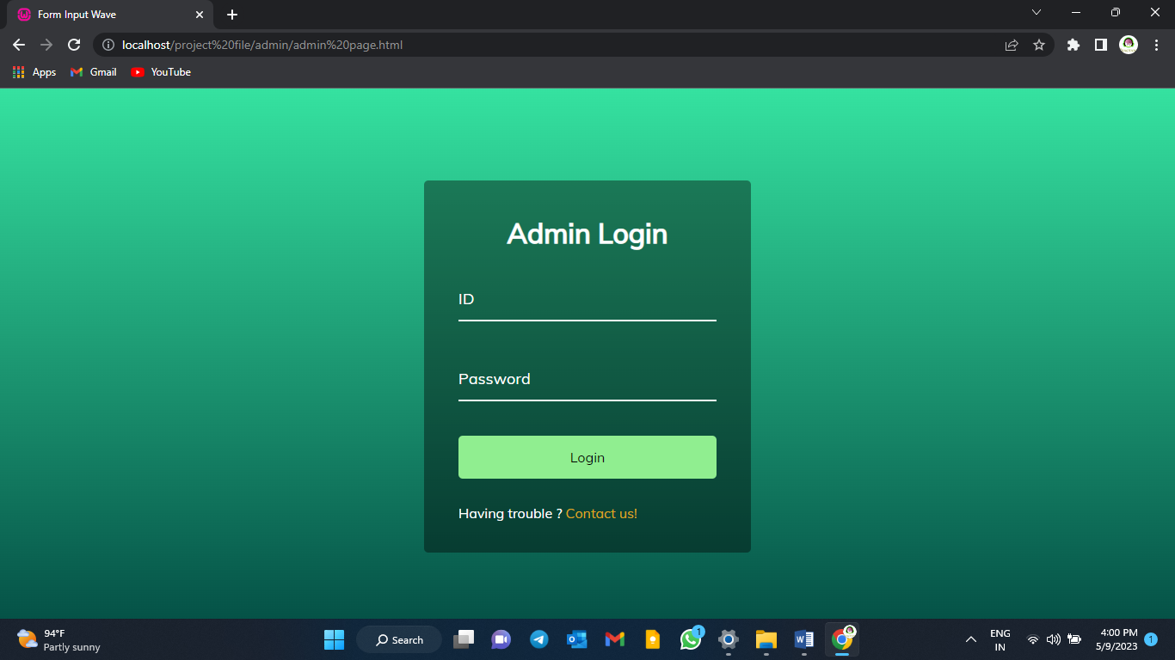

**2)Input Screen(with data):**

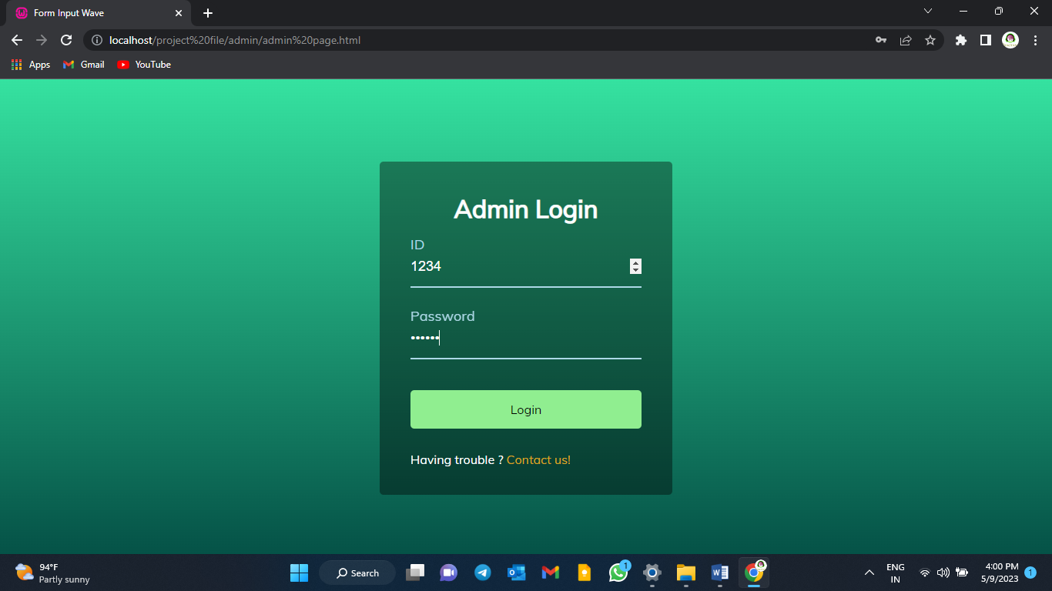

1. **Code Design:**

**(login page code )**

<html lang="en">

<head>

<meta charset="UTF-8" />

<meta name="viewport" content="width=device-width, initial-scale=1.0" />

<link rel="stylesheet" href="admin page.css" />

<title>Form Input Wave</title>

</head>

<body>

<div class="container">

<h1>Admin Login</h1>

<form action="login.php" method="post">

<div class="form-control">

<input type="number" name="ID" required>

<label>ID</label>

</div>

<div class="form-control">

<input type="password" name="PASSWORD" required>

<label>Password</label>

</div>

<button class="btn" name="submit">Login</button>

<p class="text">Having trouble ?<a href="#footer"> Contact us! </a> </p>

</form>

</div>

<script src="admin page.js"></script>

</body>

<footer id="footer"></footer>

</html>

**(registration page code)**

<!DOCTYPE html>

<html lang="en">

<head>

<meta charset="UTF-8" />

<meta name="viewport" content="width=device-width, initial-scale=1.0" />

<link rel="stylesheet" href="registration.css">

<title>Registrations</title>

</head>

<body>

<div class="container">

<div class="panel active" style="background-image: url('gusto.jpg')">

<a href="gusto.html"><h3>Click to enter Gusto Registration</h3></a>

</div>

<div class="panel" style="background-image: url('branding.jpg')">

<a href="branding.html"><h3>Click to enter Branding Team Registration</h3></a>

</div>

<div class="panel" style="background-image: url('care\ club.jpg')">

<a href="care.html"> <h3>Click to enter Care Club Registration</h3></a>

</div>

<div class="panel" style="background-image: url('champs\ club.jpg')">

<a href="Champ.html"> <h3>Click to enter Champs Club Registration</h3></a>

</div>

</div>

<script src="registration.js"></script>

</body>

</html>

1. **Limitations of the System:**

Social Media Integration: Allow users to connect their social media accounts to the website, enabling them to share event information, photos, and updates with their social network. Only available to one device not onto the cloud system to manage and access (for admin).

1. **Bibliography/References:**

* <https://www.w3schools.com>
* <https://www.geeksforgeeks.org>
* <https://openai.com>
* <https://wordpress.com>
* https://codepen.io/tianyili/pen/qBEdeoy
* <https://unsplash.com>
* https://github.com/bradtraversy/50projects50days
* https://universe.ai
* <https://css-tricks.com/can-get-pretty-far-making-slider-just-html-css/>
* <https://matchingxl.com>
* <https://github.com>
* <https://www.mockupworld.co>
* https://www.freepik.com/free-photos-vectors/mockup